**ASSIGNMENT 5.5B**

**on**

**Infrastructure as code**

**Submitted by:**

**Haseebullah Shaikh (2303.KHI.DEG.015)**

**Faiza Gulzar Ahmed (2303.khi.deg.001)**

**and**

**Aqsa Tauheed (2303.khi.deg.011)**

**Dated:** 22nd May 2023

**Solution:**

**Created files for creating module S3_data.tf, variables.tf, output.tf.**

Created three resources in module file.

1. To create bucket named: Haseebullah-shaikh-bucket
2. To set acl value, for making it to private use only
3. To add give folder directory “day2IaC/

Variables that are assigned in following s3_data.tf are defined in variables.tf also output file is created separately, which will be access in main.tf where this module will be called as source.

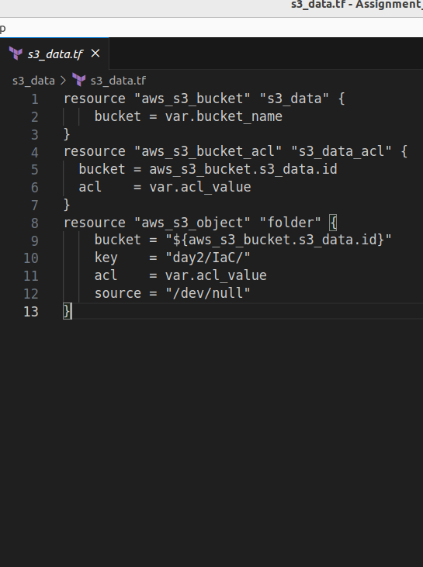

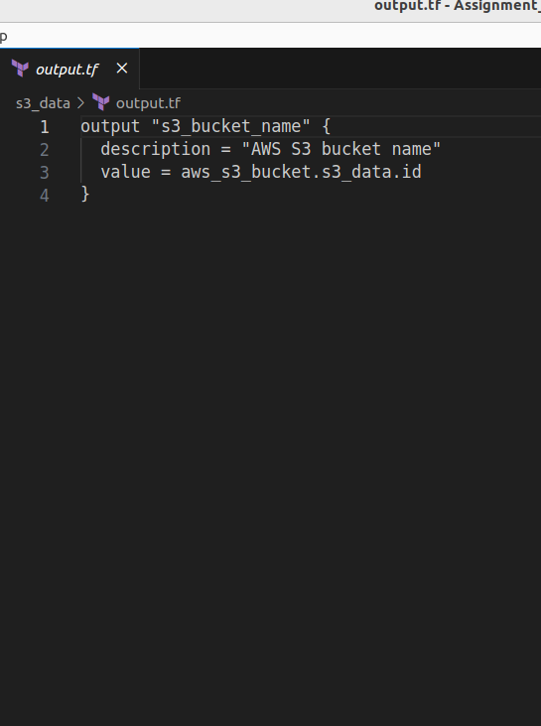

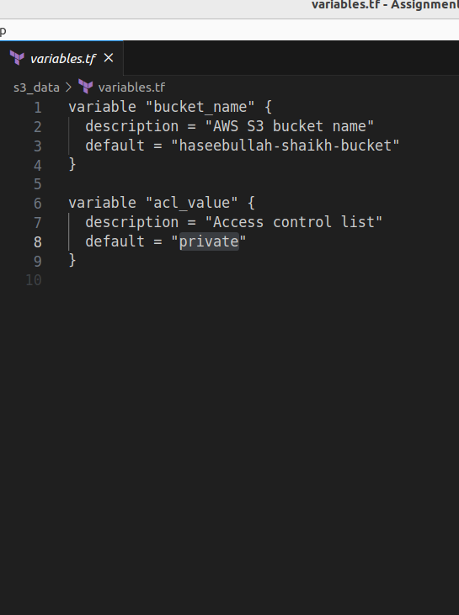

**Main.tf to access created module, the module is accesed through file path ./s3_data,**

**Variables that are assigned are defined in separate file named variables.tf**

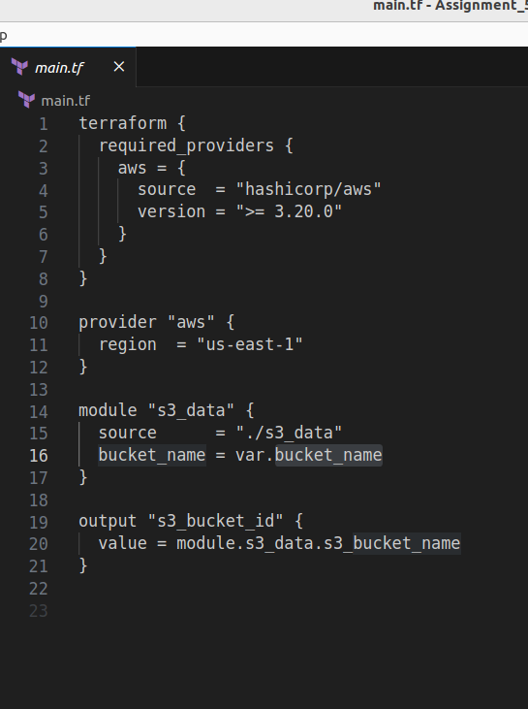

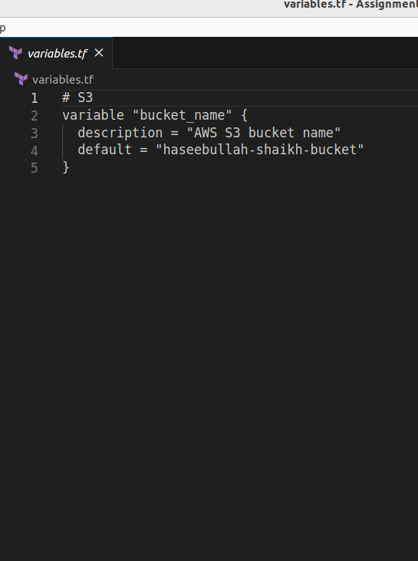

**Commands to create the bucket**

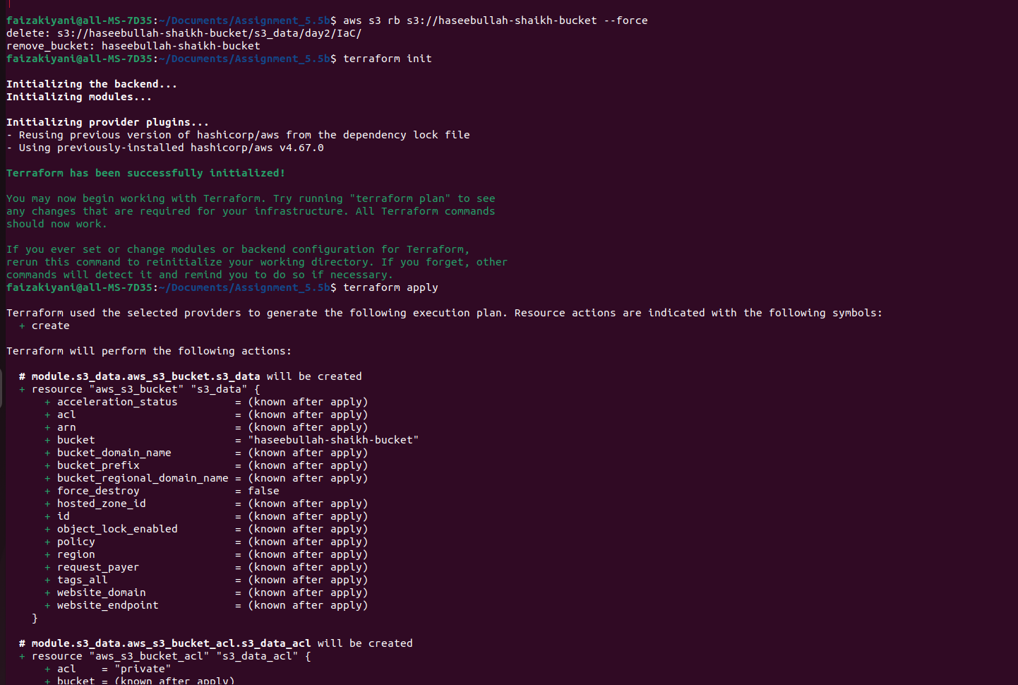

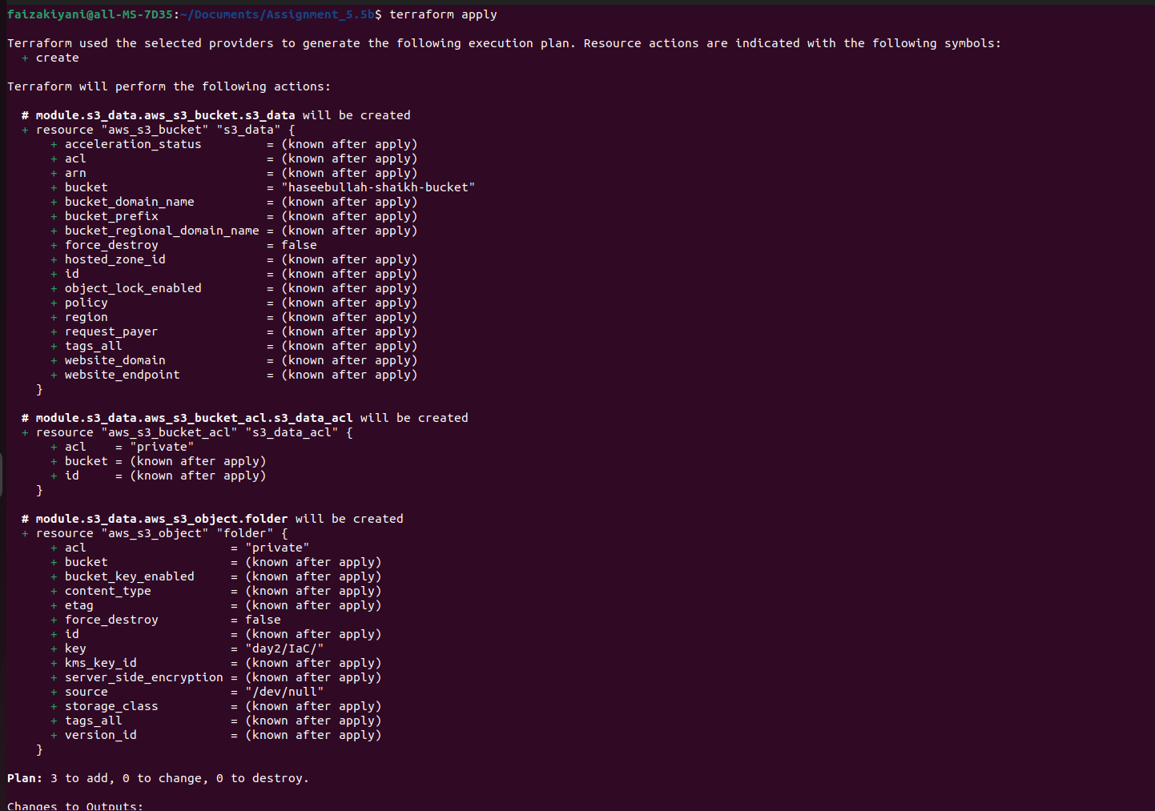

**Verifying bucket is created with given folder directory.**

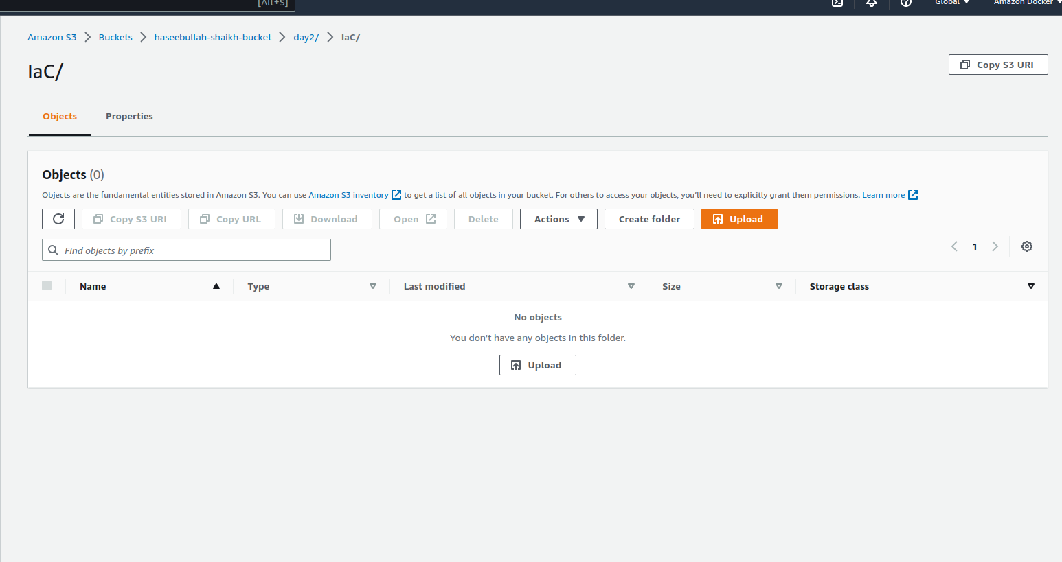

**Command to print bucket it to the output**

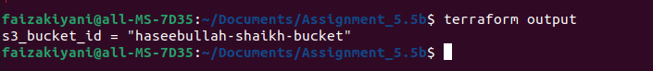

**Command to destroy the bucket**

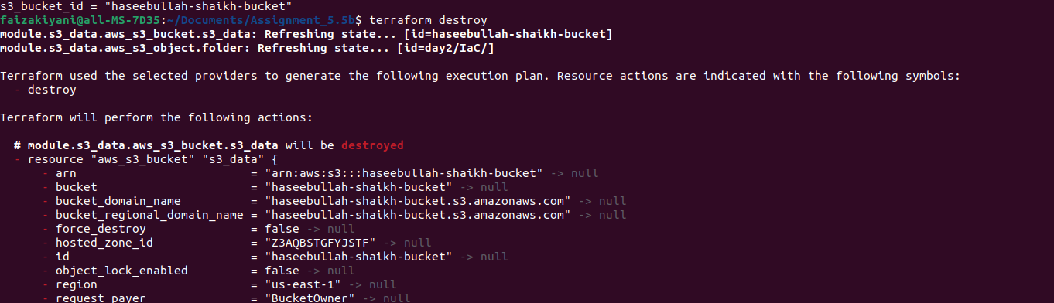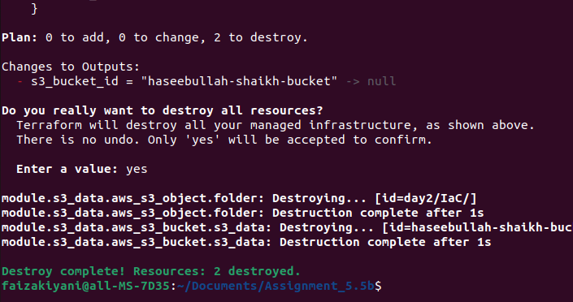

**The End ☺**